Simulation of Robot Dynamics and Control using Simulink Software
Mustafa Turki Hussein
Dept. of Mechanical Engineering, Collage of Engineering Babylon university
Abstract
Simulations of dynamic system and two control approaches used to control an industrial IRIS robot manipulator using a software package Simulink, based on the robotics toolbox in MatLab program. The robot dynamic model of four degrees of freedom was derived using the same software. Two types of control problems was studied computed torque control, and feedforward control; by building a Simulink models for the two types of controllers. The two types of control models are simulated under same conditions and the results from simulations were compared.
الخلاصة
في هذا البحث تم دراسة المحاكاة الديناميكية وكذلك استخدام نوعين من أنواع السيطرة مع إنسان آلي من النوع الصناعي باستخدام (Simulink) وكانت أنظمة المحاكاة مبنية بالأساس على صندوق الأدوات الخاص بالإنسان الآلي في برنامج MatLab. تم اشتقاق معادلة الحركة للإنسان الآلي الذي يملك أربع درجات حرية باستخدام نفس صندوق الأدوات وكذلك تم دراسة نوعين من المسيطرات على الحركة : الأولى هي باستخدام عزم الحركة المحسوب, والثانية هي التغذية باتجاه الأمام من خلال بناء النماذج داخل برنامج (Simulink). تم إجراء المحاكاة للنوعين من المسيطرات تحت نفس ظروف الحركة وتم مقارنة النتائج.
- Introduction
Most automated manufacturing tasks are done by special-purpose machines that are designed to perform prespecified functions in a manufacturing process. The inflexibility of these machines makes the computer-controlled manipulators more attractive and cost-effective in various manufacturing and assembly tasks. Today's industrial robots, though controlled by mini-/microcomputer, are basically simple positional machines. A given task had been exacted by playing back prerecorded or preprogrammed sequences of motions that have been previously guided or taught by a user with a hand-held control/teach box. Moreover, because the robots are equipped with few or no external sensors (both contact and noncontact), they cannot obtain vital information about their working environment. More research needs to be directed towards improving the overall performance of the manipulator systems, and one way is through the study of robot arm kinematics, dynamics, and control[Jorge Angeles 2003].
The purpose of robot arm control is to maintain the dynamic response of a computer-based manipulator in accordance with some prespecified system performance and goals. In general, the control problem consists of obtaining suitable dynamic models of the physical robot arm for designing the controller and specifying corresponding control laws or strategies to achieve the desired system response and performance. This article details the feedforward, and computed torque technique in the joint-variable space.
Simulink is a software package for modeling, simulating, and analyzing dynamic systems. It supports linear and nonlinear systems, modeled in continuous time, sampled time, or a hybrid of the two. Systems can also be multirate, i.e., have different parts that are sampled or updated at different rates. The MatLab and Simulink environments are integrated into one entity, and thus analyzing, simulation, and revising the models can be done in either environment at any point [Steven 2006], and if Behind every robotic movement is a series of complex geometric evaluations and equations that describe motion dynamics. Conformance to system goals must also be considered; control prototyping with Simulink allows a designer to conceptualize control solutions by means of block diagram driven environment. There is no need to use the production software and hardware during the design process thereby cutting down the cost in design. moreover, the designer can also refine the system model iteratively and tune controller parameters. these features help to reduce the implementation time, which is important in many industry situation. teaching of rapid control prototyping concept is getting acceptance by many academics in leading institutions[F C Teng 2000].
In this work the simulation of dynamic and control of robot manipulator was done by using MatLab/Simulink software; were the robotics toolbox for MatLab[Peter I. Corke 1996] was used in the modeling and simulation process. Two types of control problems was studied by using Simulink namely: feedforward control and computed torque control. to check the advantage of the of using Simulink in robot modeling and simulating the robot model chosen as industrial robot.

- Robot Dynamics
Robot arm dynamics deals with the mathematical formulations of the equations of robot arm motion. The dynamic equations of manipulator motion are a set of equations describing the dynamic behavior of the manipulator. Such equations of motion are useful for computer simulation of robot arm motion, the design of suitable control equations for a robot arm, and the evaluation of the kinematic design and structure of a robot arm.
Various approaches are available to formulate robot arm dynamics, such as the Lagrange-Euler, the Newton-Euler, the recursive Lagrange-Euler, and the generalized d'Alembert principle formulations [Spong and Vidyasagar 2001]. Deriving the dynamic model of a manipulator using the L-E method is simple and systematic. The resultant equations of motion, excluding the dynamics of the electronic control device and the gear friction, are a set of second order, coupled nonlinear differential equations.
One approach that has the advantage of both speed and accuracy is based on the N-E vector formulation[Peter I. Corke 1996] was used in this work. The derivation is simple, although messy, and involves vector cross-product terms. The resultant dynamic equations, excluding the dynamics of the control device and the gear friction, are a set of forward and backward recursive equations. These equations can be applied to the robot links sequentially. There are two problems related to manipulator dynamics that are important to solve:
- inverse dynamics in which the manipulator’s equations of motion are solved for given motion to determine the generalized forces. and
- direct dynamics in which the equations of motion are integrated to determine the generalized coordinate response to applied generalized forces.
The equations of motion for an n-axis manipulator are given by:
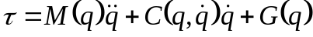 (1)
where: if we have 4DOF 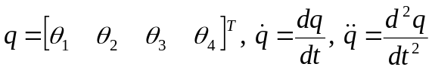
Obtaining the dynamic equations of motion using the MatLab program(robotics toolbox) was very powerful process; the toolbox use N-E approach to compute the equation of motion by feeding the program by necessary data about the robot system by using the functions(dyn.m, robot.m) to introduce the robot object in the MatLab program, the robot object then can be used in the MatLab program to define Simulink blocks. Because of the nature of the formulation and the method of systematically computing the torques, computations are much simpler, allowing a short computing time. With this algorithm, about three milliseconds are needed to compute the feedback joint torques per trajectory set point.
- Robot Control
Robot control is the spine of robotics. It consists in studying how to make a robot manipulator do what it is desired to do automatically; hence, it includes in designing robot controllers. Typically, these take the form of an equation or an algorithm which is realized via specialized computer programs. Then, controllers form part of the so-called robot control system which is physically constituted of a computer, a data acquisition unit, actuators (typically electrical motors), the robot itself and some extra “electronics” . In this work two types of control problems was studied feedforward control and computed torque control.
3.1Computed Torque Control
In order to overcome drawbacks of the PD controller, a more sophisticated scheme in which the magnitude of the nonlinear disturbing and loading torques is computed using the dynamic equations and used to compensate these disturbances by means of a feedforward may be employed. It must be noted that the basic control method is still PD controller with both position and velocity feedback[Rafeal and James , 1991].
The dynamic model (1) that characterizes the behavior of robot manipulators is in general, composed of nonlinear functions of the state variables (joint positions and velocities). This feature of the dynamic model might lead us to believe that given any controller, the differential equation that models the control system in closed loop should also be composed of nonlinear functions of the corresponding state variables. Nevertheless, there exists a controller which is also nonlinear in the state variables but which leads to a closed-loop control system which is described by a linear differential equation. This controller is capable of fulfilling the motion control objective.
The computed-torque control law is given by[ Kelly et. al. 2005]:

(2)

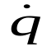
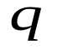
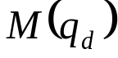
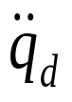
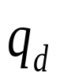
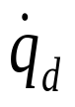
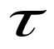
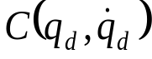
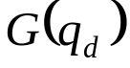
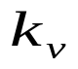
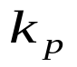
where the gains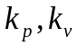 are chosen to meet some specific properties of the system and these gains should be adjusted to reduce the errors[Kelly and Salgado 1994]. The block diagram that corresponds to computed-torque control of robot manipulators is presented in Figure 1.
∑
∑
Robot
Figure 1. Block-diagram: computed torque control.
∑
∑

  - Feedforward Control
Among the conceptually simplest control strategies that may be used to control a dynamic system we find the so-called open-loop control, where the controller is simply the inverse dynamics model of the system evaluated along the desired reference trajectories. For the case of linear dynamic systems, this control technique may be roughly presented as follows [Kelly 2005]: by using (1) applying a torque at the input of the robot, the behavior of its outputs and are governed by:
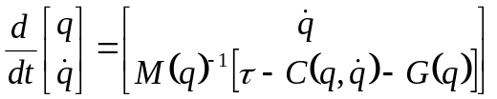 (3)
If the behavior of the outputs and need to be equal to that specified by 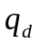 and 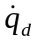 respectively, it seems reasonable to replace , and by , , and 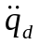 in the Eq. (2) and to solve for . This reasoning leads to the equation of the feedforward controller, it can be expressed as:
(4)
In figure 2 the block-diagram corresponding to a robot under feedforward control is presented ; the control action does not depend on nor on , that is, it is an open loop control.
The wide practical interest in incorporating the smallest number of computations in real time to implement a robot controller has been the main motivation for the PD plus feedforward control law, Feedforward control (3) may be modified by the addition, of a feedback Proportional–Derivative (PD) term shown in figure 3. given by:
(5)

∑
∑
Robot
inverse dynamic
direct dynamic
Figure 2. Block-diagram: feedforward control.

∑
∑
Robot
Figure 3. Block-diagram: PD plus feedforward control.

Dynamic
Model
∑

- Simulink Model
The robot model studied in this work is the IRIS robot manipulator where all kinematic and dynamic parameters are illustrated in the appendix A, the dynamic model for this robot system is a highly nonlinear differential equation due to the coupled between different degrees of freedom(4DOF). The modeling of the robot system was done using Robotics Toolbox in the MatLab program, using the functions(dyn.m, robot.m) to introduce the robot object in the program and then the robot object can be used with two way dynamics; The forward recursion propagates kinematics information-such as angular velocities, angular accelerations, linear accelerations, total forces and moments exerted at the center of mass of each link-from the base reference frame (inertial frame) to the end-effector. The backward recursion propagates the forces and moments exerted on each link from the end effector of the manipulator to the base reference frame. using the inverse and the direct dynamic functions which are very important in the usage of dynamic block of Simulink in the robot control simulation.
The IRIS system was simulated using Simulink program under the robot control techniques which are stated in the previous section. Computed torque control approach Simulink model shown in figure 4, feedforward control approach Simulink model shown in figure 5.

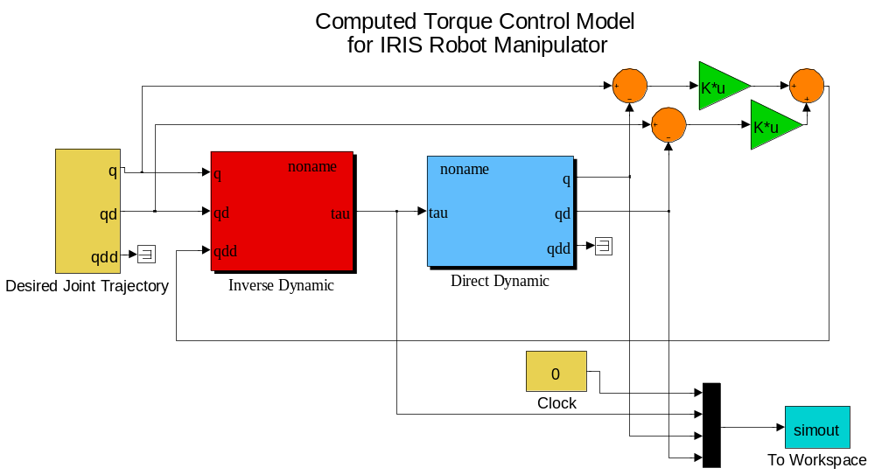
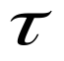
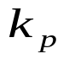
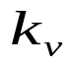

Figure 4. Computed torque control Simulink model for IRIS robot manipulator.

−
−
IRIS
IRIS

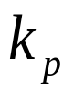

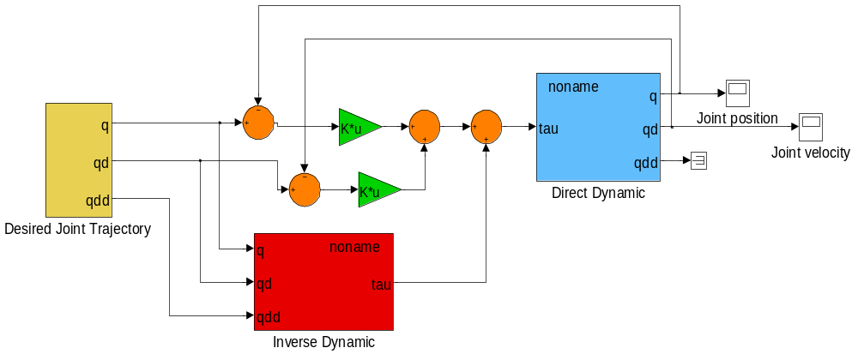
Figure 5. Feedforward control Simulink model for IRIS robot.
IRIS
IRIS
−
−
+
+
+
+
+
+

- Simulation Results
In this section, performances of different controllers for a full motion of the IRIS robot is evaluated. The computation of the dynamics for the full robot model is much more complicated than the single joint case due to gravity and coupling effects between joints. Some robot controllers, therefore, compensate for only a part of these effects. In this article the integral feedback term has been not included; since the interesting in the dynamic trajectory errors rather than in the steady state errors, which can be reduced by the integral term. The gains and adjusted to achieve acceptable performance. The reference trajectory of the movement studied is generated by a fifth order polynomial, which gives smooth velocities and accelerations. For this smooth trajectory, the joint moves from 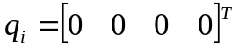 to 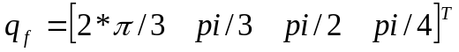in 6s. The evaluations of the following two control methods mentioned before used for high speed movements of all four joints of the manipulator include the following:
- Computed torque control.
- Feedforward control.
The values of the gains and were adjusted to reduce the trajectory and velocity errors and the values chosen as 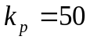, and =10 for all joints. The trajectory errors for the first of the above 2 controllers are shown on Figure 6., and the velocity errors are shown in Fig. 7, the trajectory errors and the velocity errors for the first controller can be considered a large; With this controller, the peak trajectory errors are 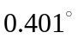, 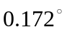,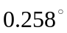and 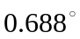 for joints 1, 2, 3, and 4 respectively. The trajectory and velocity errors for the feedforward controller are shown on Figures 8 and 9., and these errors can be considered more acceptable from the first controller; With this controller, the peak trajectory errors are 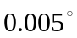, 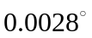,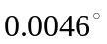and 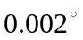 for joints 1, 2, 3, and 4 respectively.
Figures 10 and 11 shows the input torques for the joint moves from 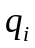to 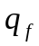 in 6 sec of two types of controller, the difference between values of input torques for the two types was very small and can be considered unperceptible.

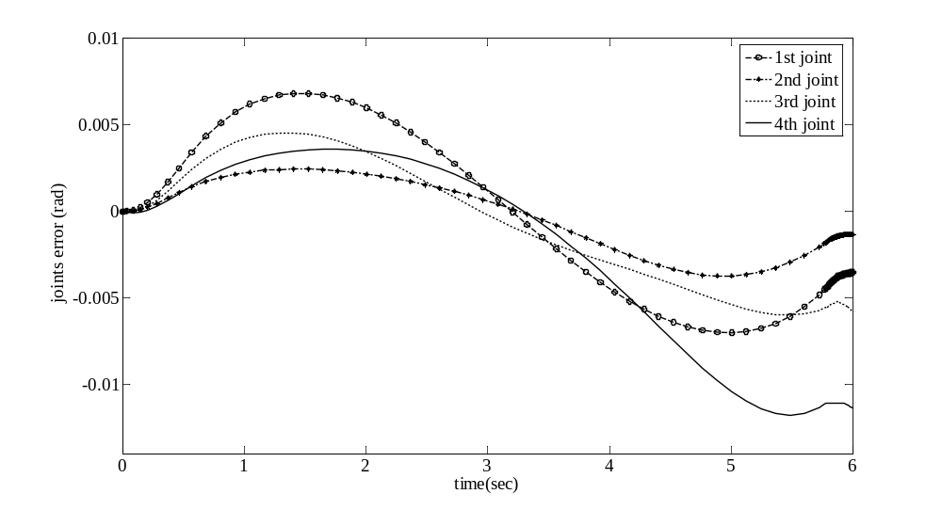
Figure 6. Trajectory errors of computed torque control.

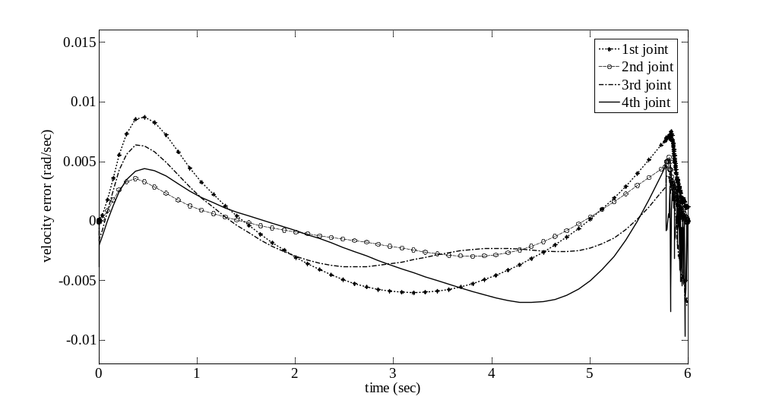
Figure 7. Velocity errors of computed torque control.

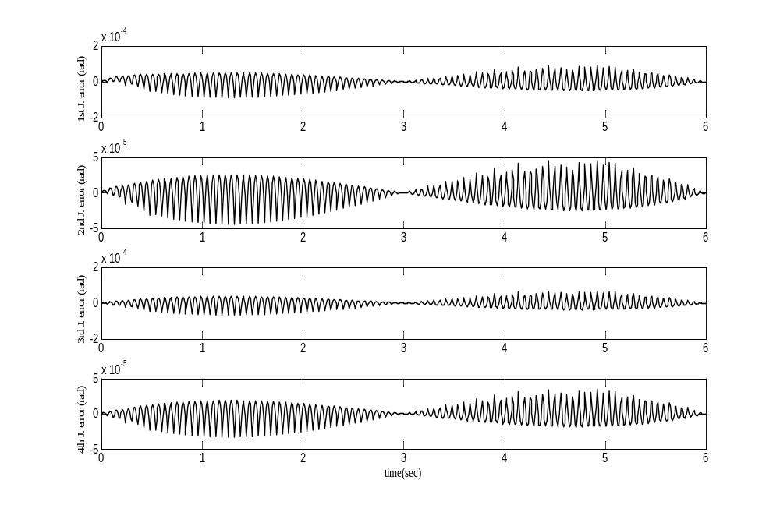
Figure 8. Trajectory errors of feedforward control.

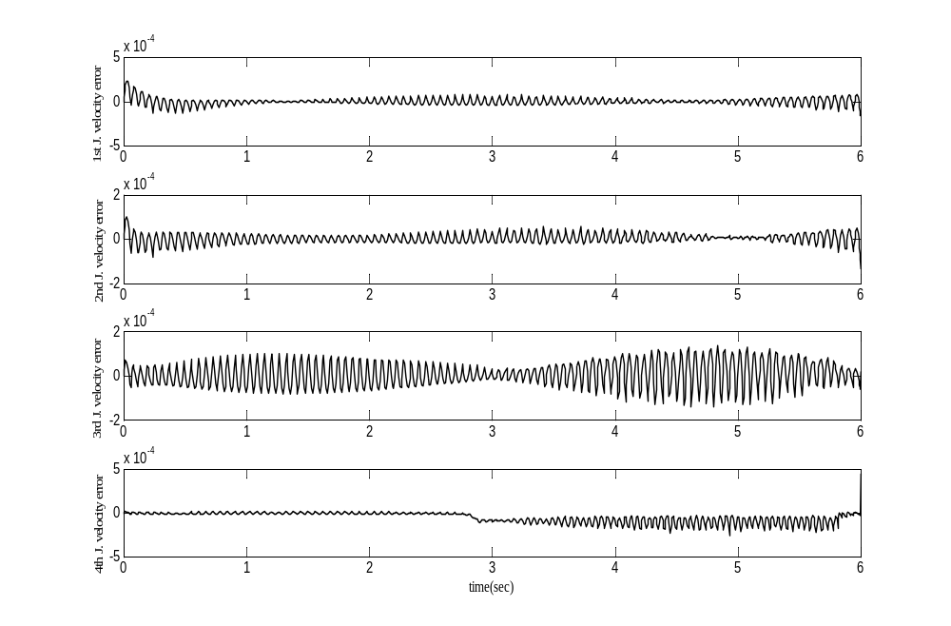
Figure 9. Velocity errors of feedforward control.

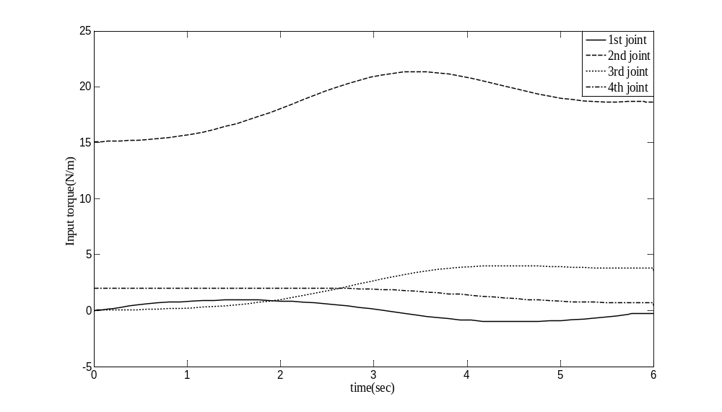
Figure 10. simulated Input torque of the computed torque controller.

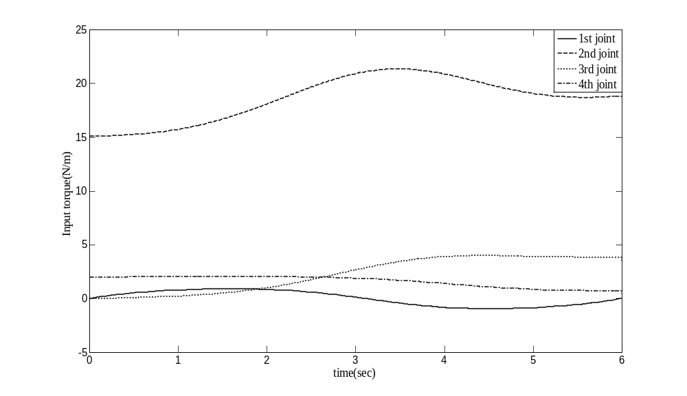
Figure 11. simulated Input torque of the feedforward controller.

- Conclusions
In this paper the simulation of the dynamic system and two types of control for robot manipulator was done by using a Simulink based on robotics toolbox. the models derived in this paper was very effected and can easily be used the controller and also can be easily regulate the gains of controllers presented some simulation results of using derived dynamic model of the manipulator for dynamic CTC and feedforward control. The results indicate that feedforward control can improve the trajectory following accuracy significantly. Such a performance using feedforward compensation also indicates that the estimated rigid body model of the manipulator is quite accurate and adequate for control purposes for all joints.

- References
Jorge Angeles, 2003 "Fundamentals of Robotic Mechanical Systems: Theory, Methods, and Algorithms", Second Edition, Springer-Verlag, New York.
Kelly R., Salgado R., 1994 "PD control with computed feedforward of robot manipulators: A design procedure", IEEE Transactions on Robotics and Automation, Vol. 10, No. 4, August, pp. 566–571.
Kelly, R., Santibanez V. and Loria, A. 2005 "CONTROL of ROBOT MANIPULATOR in JOINT SPACE", Advanced Textbooks in Control and Signal Processing, Springer-Verlag London.
M. Spong and M. Vidyasagar, 2001 "ROBOT MODELING and CONTROL", John Wiley and Sons INC., London.
Mohammad Reza Emami, 1997 "Systematic Methodology of Fuzzy-Logic Modeling and Control and Application to Robotics", Master thesis, Dept. of Mechanical and Industrial Engineering, University of Toronto.
Peter I. Corke, 1996 "Robotics TOOLBOX for MATLAB (Release 7.1)", IEEE Robotics and Automation Magazine, Vol.3, No. 1, pp. 24-32.
Rafeal M. Inigo, and James S. Morton, 1991 "Simulation of the Dynamics of an Industrial Robot", IEEE transaction on Education, Vol. 34, No. 1, pp.89-99.
Steven T. Karris, 2006 "Introduction To Simulink With Engineering Applications", Orchard Publications, United States of America.
Teng, F. C. 2000 "Real Time Control using MatLab and Simulink", IEEE press.

Nomenclature:
: vector of generalized joint coordinates describing the pose of the manipulator.
: vector of joint velocities.
: vector of joint accelerations.
: vector of desired generalized joint coordinates describing the pose of the manipulator.
: vector of desired joint velocities.
: vector of desired joint accelerations.
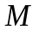 : symmetric joint-space inertia matrix, or manipulator inertia tensor.
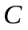 : Coriolis and centripetal effects; Centripetal torques are proportional to 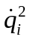; while the Coriolis torques are proportional to 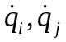.
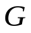 :gravity loading.
: vector of generalized torques or forces associated with the generalized coordinates .
: are symmetric positive definite matrices, called gains of position and velocity respectively.
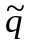 vector of joint errors.
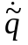 vector of joint velocity errors.
IRIS: Intelligent Robot Industrial System.

Appendix A: Robot Model Studied
Figure 12 illustrates the geometric form of the robot manipulator studied in this paper, and the kinematics and dynamic parameters are listed in the tables 1[Mohammad Reza 1997], below.
Table 1. kinematics parameters of IRIS robot
Link  i | 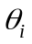 | 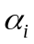  (deg) | 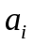  (m) | 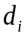  (m) | Mass  (kg) | Center of  mass (m) | Inertia matrix (kg.m²)
1 | 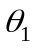 | 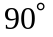 | 0.28 | 0 | 4.023 | 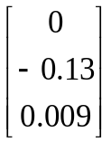 | 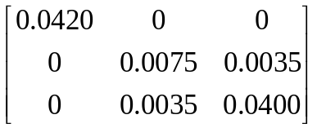
2 | 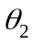 |  | 0.32 | 0 | 2.191 | 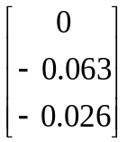 | 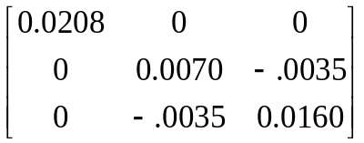
3 | 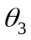 |  | 0 | 0.25 | 2.81 | 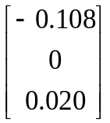 | 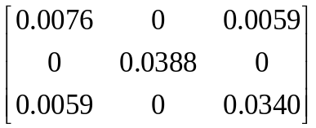
4 | 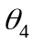 | 0 | 0 | 0.19 | 1.385 | 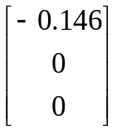 | 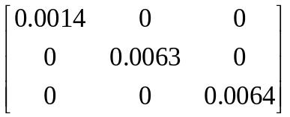
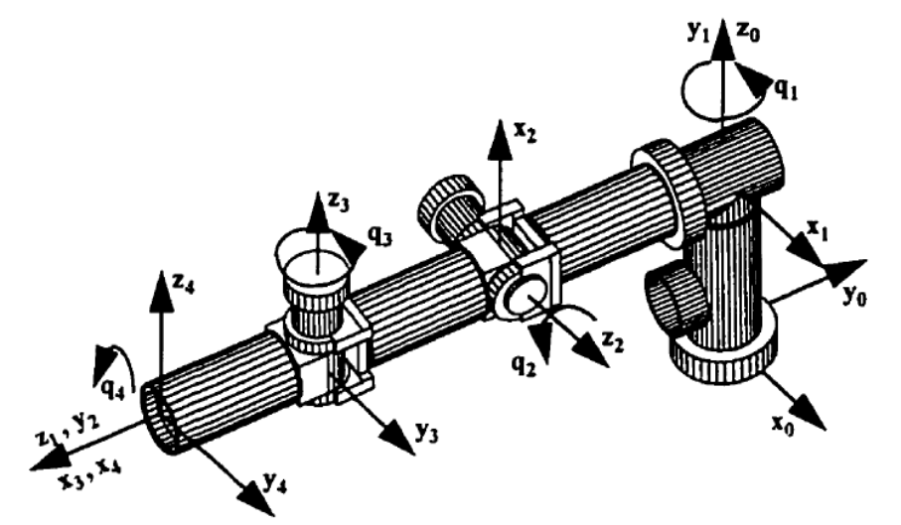
Figure 12. The desired configuration of the IRIS robot with the link coordinate frames.

